Saadiq Jattiem ST10303758

PROG6212 POE

Contents

Introduction 2

Design changes 3

Main Window 3

Create Account window 4

Lecturer login window 5

Lecturer Dashboard 5

Program Coordinator window 6

Programme coordinator dashboard 6

Submit Claim 7

Supporting Doc 8

View claims window 8

HR VIEW 9

Github repository link 9

Github Commit history 10

Database structure 11

Database layout 12

Account user table 12

Claims table 13

Supporting docs 13

Workflow 13

For lecturers: 13

For Coordinators: 13

# Introduction

In this part of the POE we are supposed to discuss the designs done in part 1 through the creation of functionality and establishment of project flow. I was supposed to change what was needed from the feedback of part 1 and try to improve part 2 by using the feedback given.

While I did not get much feedback because I got high marks I tried to make some improvements to my part 2 and keep the design as simple as possible in order for the users to be able to use it with ease.

This report will explain all changes made to the application and further include screenshots.

# Design changes

Based on design changes not much has changed I just added a color scheme and the buttons and fonts were changed.

## Main Window

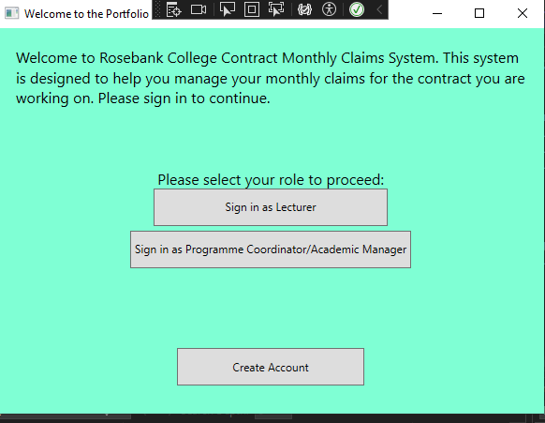

## Create Account window

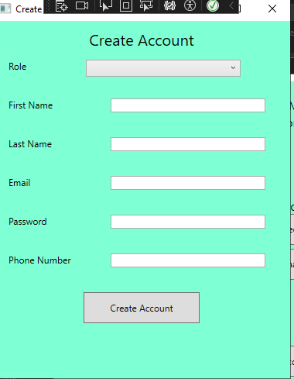

## Lecturer login window

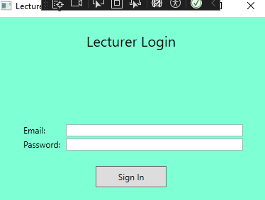

## Lecturer Dashboard

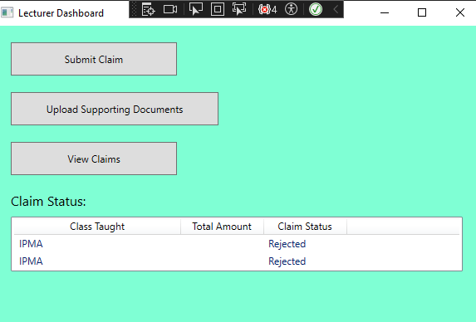

## Program Coordinator window

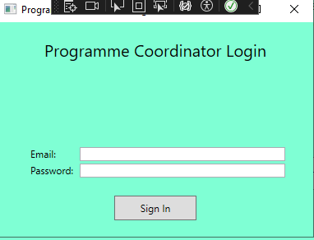

## Programme coordinator dashboard

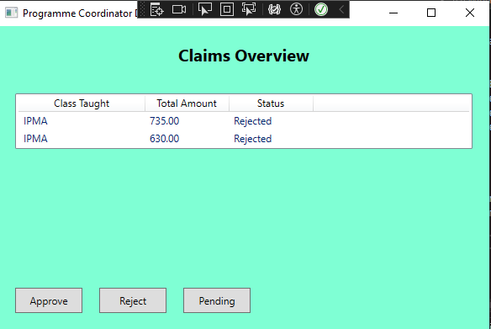

## Submit Claim

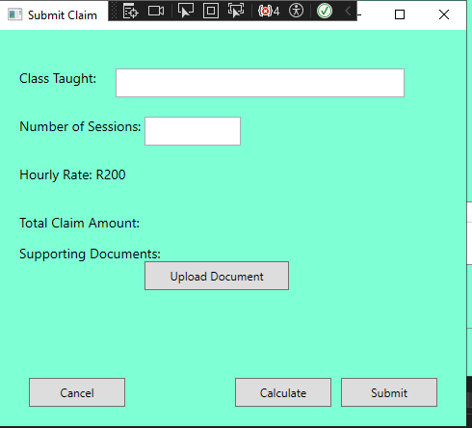

## Supporting Doc

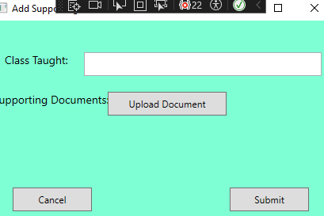

## View claims window

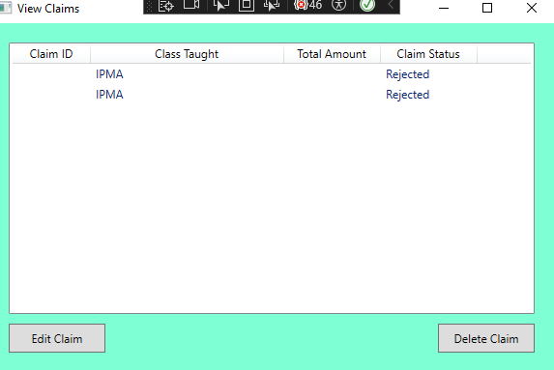

# HR VIEW

The new feature HR view automatically approves users claims if it is set to “PENDING” and it allows users to update lecturer information if they search for their name and surname, it will allow generate a report based on approved claims and it will download it.

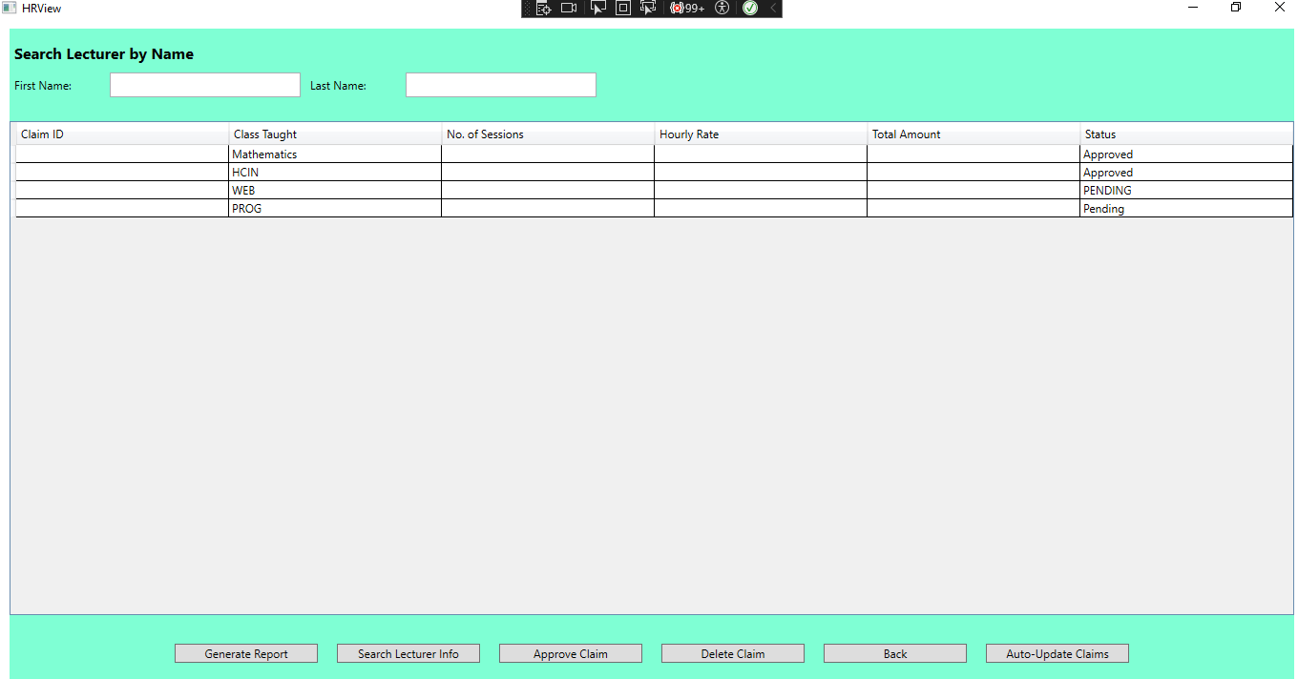

# Github repository link

<https://github.com/Saadiq1234/Saadiq_Jattiem_POE_PROG6212.git>

# Github Commit history

s

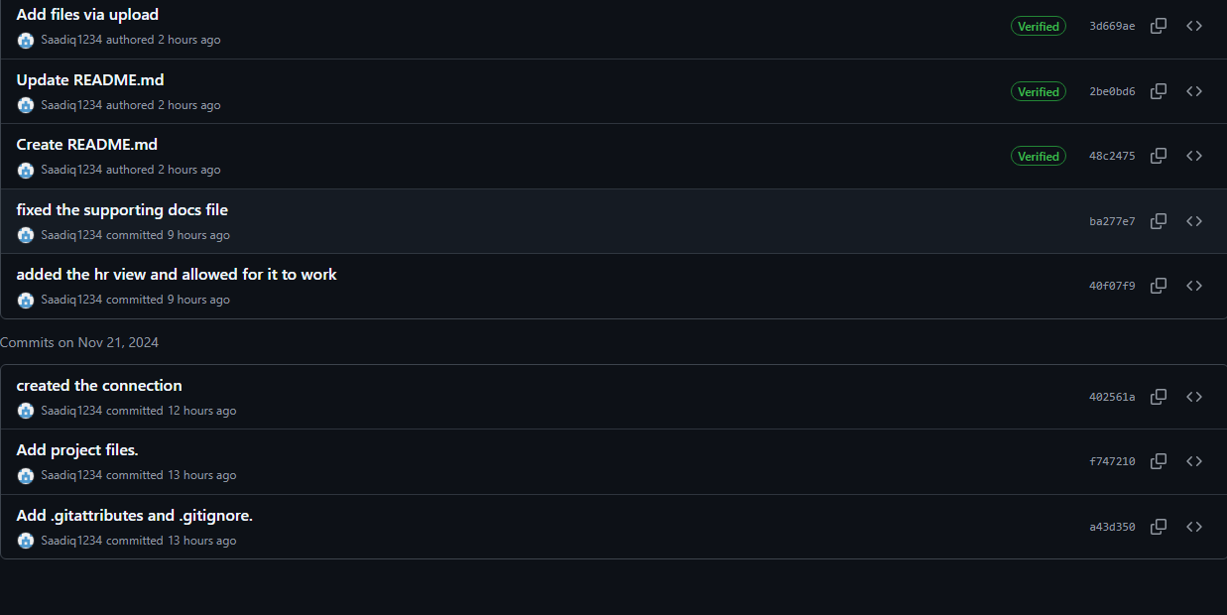

# Database structure

CREATE DATABASE POE;

USE DATABASE POE;

-- Create the Lecturer table

CREATE TABLE AccountUser(

AccountUserID INT IDENTITY(1,1),

FirstName VARCHAR(50) NOT NULL,

LastName VARCHAR(50) NOT NULL,

Email VARCHAR(100) NOT NULL,

PhoneNumber INT NOT NULl,

PasswordHash VARCHAR(255) NOT NULL,

AccountType NVARCHAR(50) NOT NULL,

PRIMARY KEY (AccountUserID),

);

-- Create the Claims table

CREATE TABLE Claims (

ClaimsID INT PRIMARY KEY IDENTITY(1,1),

ClassTaught VARCHAR(100),

NoOfSessions INT NOT NULL,

HourlyRatePerSession DECIMAL(10, 2) NOT NULL,

SupportingDocumentPath NVARCHAR(255),

ClaimStatus NVARCHAR(50) CHECK (ClaimStatus IN ('Pending', 'Approved', 'Rejected')),

ClaimTotalAmount AS (NoOfSessions * HourlyRatePerSession) -- Computed column

);

-- Create the Supporting Documents table

CREATE TABLE SupportingDocuments (

DocID INT PRIMARY KEY IDENTITY(1,1)

DocName VARCHAR(100) NOT NULL,

FilePath VARCHAR(255) NOT NULL,

SubmissionDate DATETIME NOT NULL

);

-- Create the Claims Status table

CREATE TABLE ClaimsStatus (

ClaimStatusID INT PRIMARY KEY ,

ClaimStatusConfirmation NVARCHAR(50) CHECK (ClaimStatusConfirmation IN ('Pending', 'Approved', 'Rejected'))

);

# Database layout

## Account user table

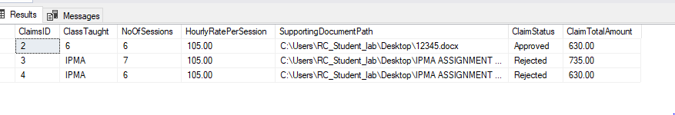

## Claims table

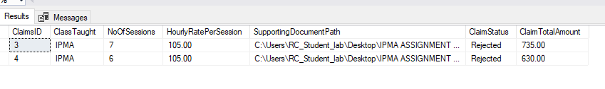

## Supporting docs

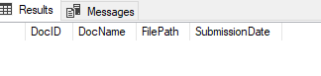

# Workflow

The flow works as follows for the program.

## For lecturers:

1.Create Account

2. Sign In

3. Go to Dashboard

4. Submit Claims

5. Add supporting docs

6.View Claims (edit or delete claims)

## For Coordinators:

1.Create Account

2.Sign In

3. Go to Dashboard

4.View Claims Submitted

5.Review (Approve/Reject/Pending